**The Global Climate Plan**

Adrien Fabre, 2024

**There is strong demand for a *global* climate policy.**

* Surveys in the G20 countries show that the global level is the most popular for implementing climate policy. They also reveal massive support (over 80%) for capping CO2 emissions, and a consensus to distribute the rights to pollute equally to every human.
* Countries in the Global South often make their decarbonization pledges conditional on transfers of resources.

The main principles of the Plan:

1. **Cap emissions in accordance with the Paris Agreement, using an Emissions Trading Scheme (ETS)**

* The plan would define a carbon budget to be broken down into yearly quotas.
* CO2 emission permits would be auctioned to emitting companies, as in the EU ETS.
* The price of carbon would encourage households and businesses to decarbonize.
* The higher prices would ultimately be paid by individuals in proportion to their carbon footprint.

1. **Use revenue to provide a global basic income and alleviate poverty**

* Proceeds would be returned to the public as a basic income to all adults.
* Each person would thus receive approximately $50/month.
* Implementation is technically possible (using e.g. smartphones and satellite internet).

1. **Form a *climate club* with carbon pricing at borders**

* The plan would enter into force as soon as the signatory entities cover 60% of global emissions (e.g. China: 30%, EU+UK: 9%, U.S.: 15%, and net beneficiary countries: 23%).
* Imports to climate club countries would be taxed in proportion to their carbon content.

1. **Include mechanisms that encourage participation of China, California, etc…**

* The Plan would allow states to join the agreement independently of the federal level, in particular by exempting them from border tariffs.
* An opt out clause for the pooling of revenues would allow countries (such as China, South Africa or Algeria) whose GDP per capita does not exceed the world average by more than 50% to retain revenues collected on their territory, avoiding them being a net contributor despite their above-average carbon footprint.

1. **Complement this Plan with other measures for climate and social justice**

* More progressive taxation to compensate the middle classes in rich countries.
* A global wealth tax funding lower-income countries to address historical responsibilities.
* Additional national climate measures are necessary to facilitate decarbonization.

**A redistribution of 0.6% of global GDP from high-income to lower-income countries.**

* The Plan would redistribute from individuals with a high carbon footprint to those with a low footprint. Individuals at the world average carbon footprint would neither win nor lose.
* At their plateau, between 2030 and 2050, revenues would correspond to approximately 2% of world GDP, including 0.6% in net transfers between countries.
* The average European person would lose €25/month in 2040, i.e. a loss of 0.6% of national income.
* The basic income would lift the 700 million living under $2/day out of extreme poverty.
* These estimates were computed with the central IPCC +2°C scenario, which implies a carbon price of around $150/tCO2 in 2030, $200 in 2040, $400 in 2050, and net zero in 2070.

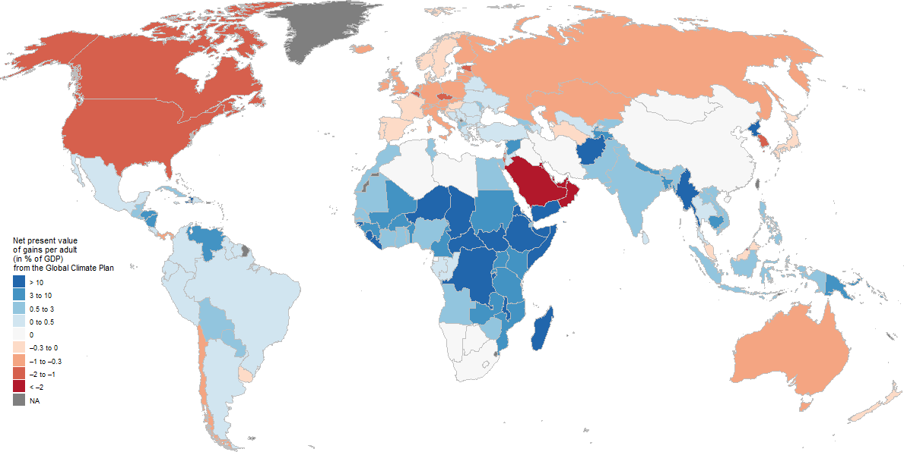

Figure 1 Financial gain (in blue) or loss (in red) following the Global Climate Plan, aggregated throughout the 21st century.

**A Plan widely supported by the public in the G20 countries**

* Representative surveys explained the Plan to respondents (emphasizing its costs) then measured support, showing 76% in Europe and 54% in the United States support the Plan.
* Different survey experiments confirm that support for global policies is sincere.
* 60% of people prefer a political program that includes the Plan to one without the Plan.
* In France, campaigning for the Plan could earn a presidential candidate 11 points in the election; and in the U.S., 3 points.

**The European Union and the Global South as strategic partners**

* It would take a Democratic trifecta for the United States to participate, because while 76% of Democratic voters support the Plan, 76% of Republicans oppose it.
* The Plan can proceed.

**Bibliography**

* The representative survey : *International Attitudes Toward Global Policies*, Adrien Fabre, Thomas Douenne & Linus Mattauch, 2023. [bit.ly/Fabre2023](https://papers.ssrn.com/sol3/papers.cfm?abstract_id=4448523)